1

**INTRODUCTION**

**TO DESIGN**

Design Basic

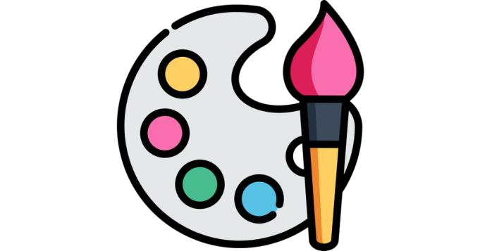

**Course evaluation**

✓Homework : 25%

10 weeks

✓Participation : 5%

March May

✓Quiz : 10%

✓Project 1: 60%

✓Teacher: MENGHEANG PHO

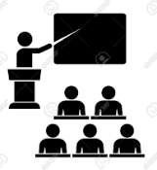

5 MIN

**who knows what is design?**

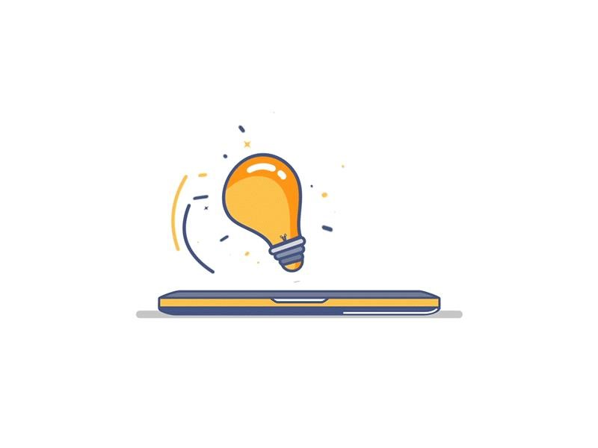**Have you heard this word before?**

**Where? By who?**

# ENGAGE



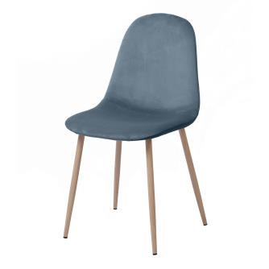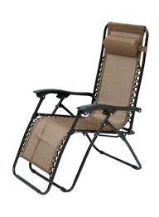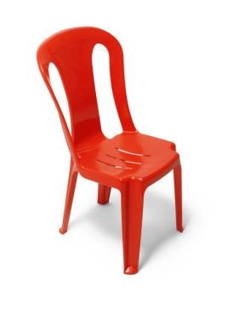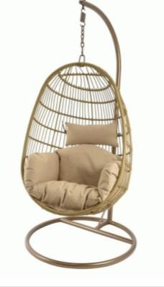5 MIN

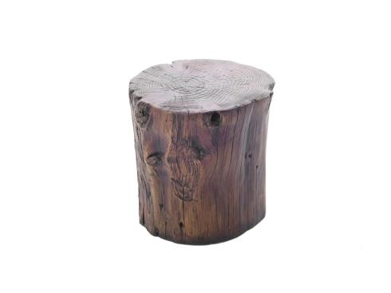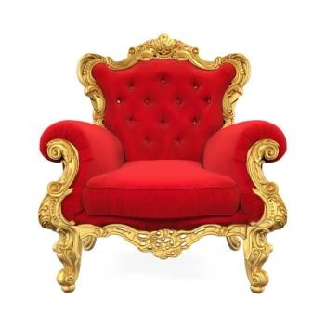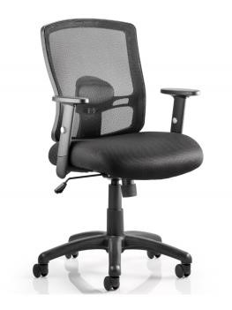

**Look at those image:**

* What are **the differences between** each **chair**?
* What are the **reasons** of those **differences**?



5 MIN

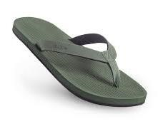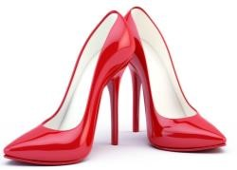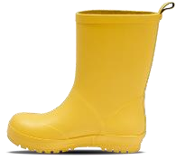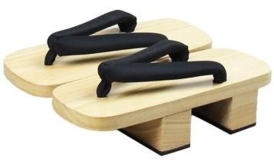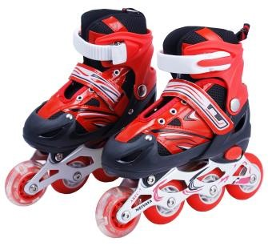**Look at those image:**

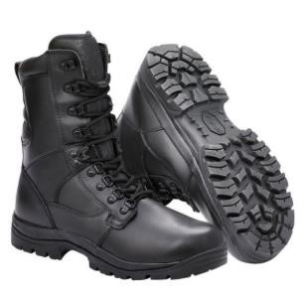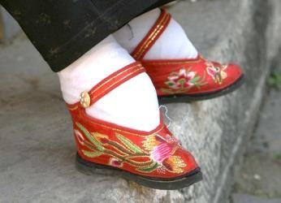

* What are **the differences between** each **shoes**?
* What are the **reasons** of those **differences**?

# EXPLAIN

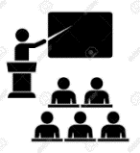

5 MIN

What is the **definition** of **Design**?

A

**v**

**isual look**

or

**shape**

given to a

**certain object**

to make it

**more attractive**

,

**more comfortable**

,

or to

**improve another characteristic**

.



**1**

**st**



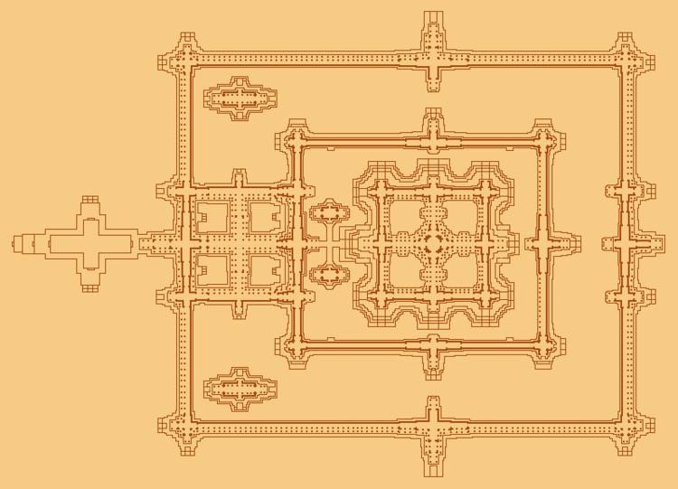5 MIN

* What is the **relation between** those **images** ?
* What is the **purpose** of the **first image**?

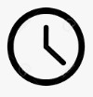

5 MIN

* What is the **relation between** those **images** ?
* What is the **purpose** of the **first image**?

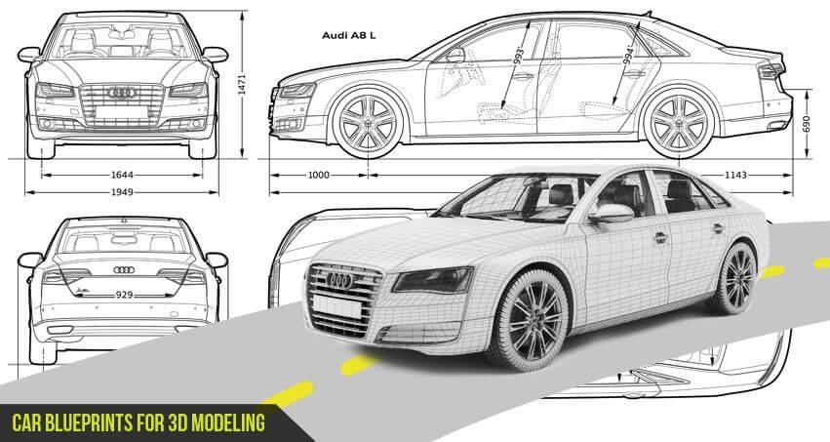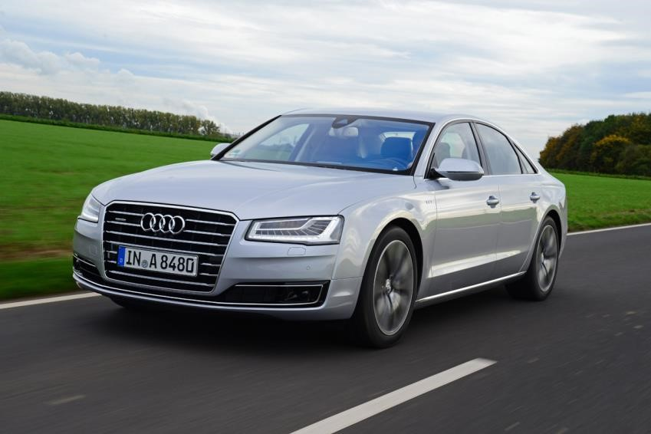



5 MIN

* What is the **relation between** those **images** ?
* What is the **purpose** of the **first image**?

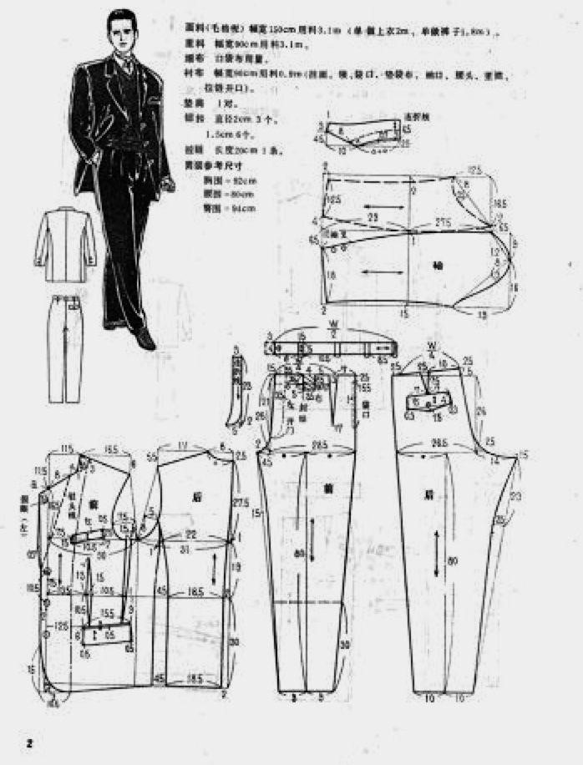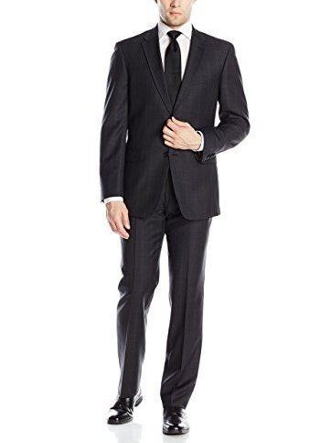



5 MIN

* What is the **relation between** those **images** ?
* What is the **purpose** of the **first image**?

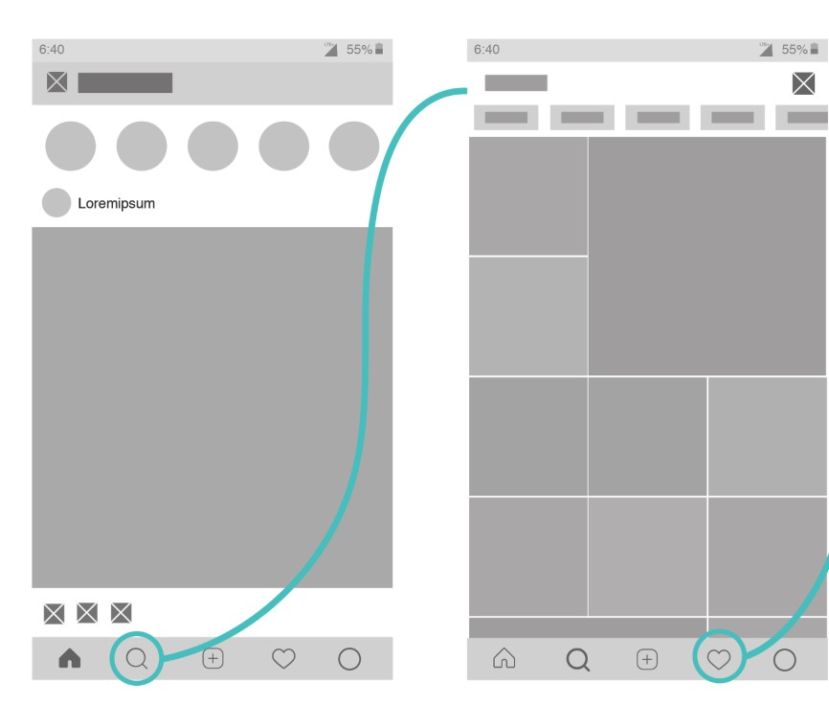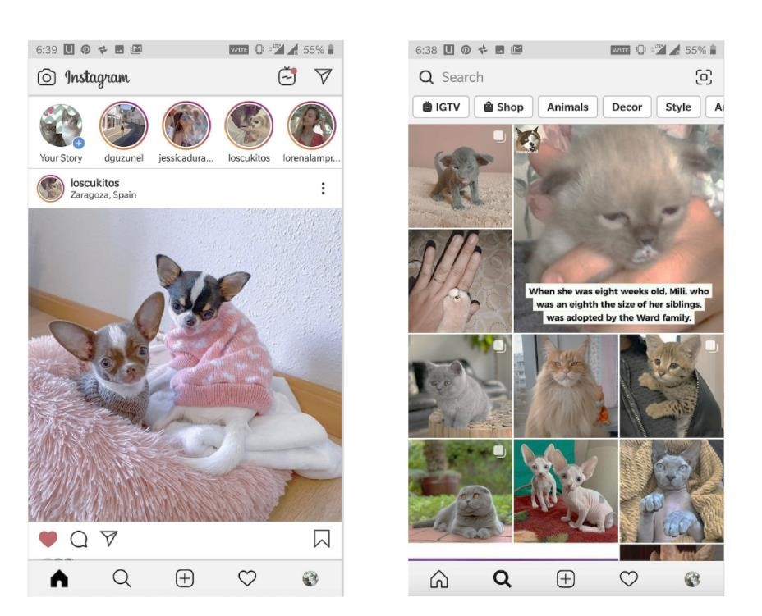

# EXPLAIN



5 MIN

What is the **definition** of **Design**?

**2nd**

A **plan** of **construction**

or the **process** used to **create** an **object** or an **image**.

# ENGAGE



5 MIN

What are the **purpose** of those **designs** ?

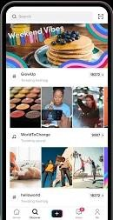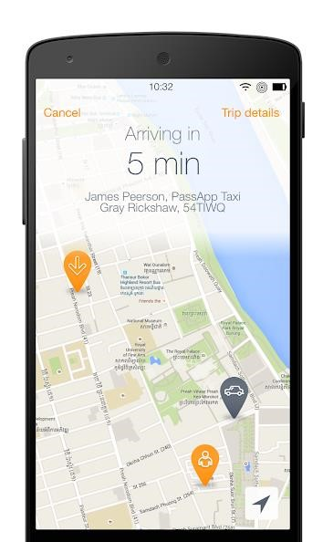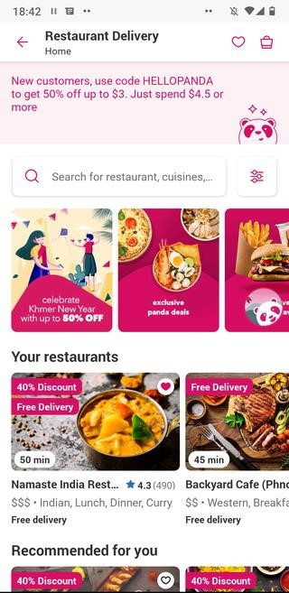

ENGAGE

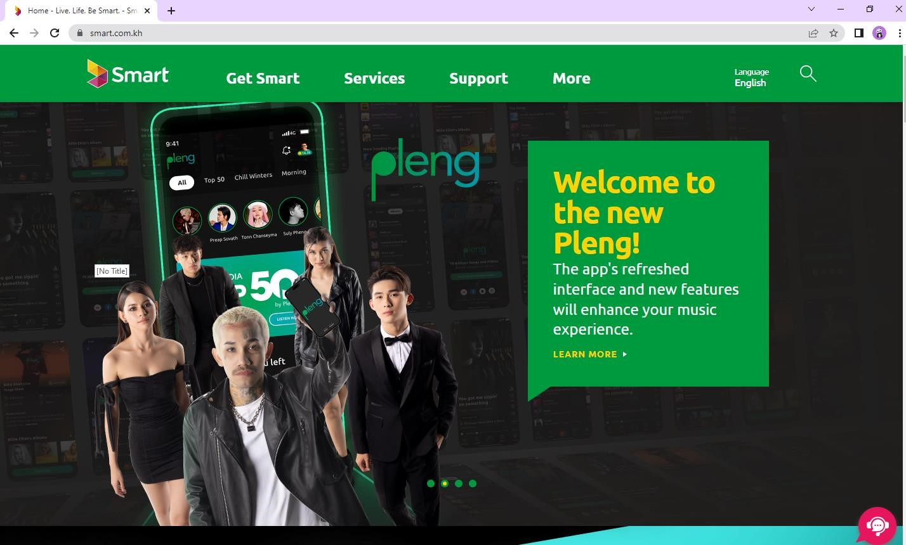

What are the

**purpose**

of those

**designs**

?



5 MIN

# EXPLAIN



5 MIN

# **Graphic Design’s goal**

**To attract**

**the right**

**customers (target)**

**To entertain,**

**amaze, surprise,**

**educate**

**...**

**To convince**

**them to buy or use**

**a service or**

**product**

## ACTIVITY

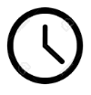

## 10 MIN ACTIVITY 1



### EXPLAIN **Point**



5 MIN

**Different positions in space have different meanings.**

|  |  |  |  |  |
| --- | --- | --- | --- | --- |
| **Top:**  Active, far, floating | **Left:** Dynamic, nervous, coming IN from left to right (in our reading direction) | **Bottom:**  Passive, close, in sleep/calm state | **Right:**  Dynamic, Calm, coming OUT  from left to right (in our reading direction) | **Centered:**  Static |

#### ACTIVITY



## 10 MIN ACTIVITY 2

*Flying*

### ENGAGE



5 MIN

**What do you see?**

### EXPLAIN

5 MIN **Line position and orientation:**



|  |  |  |
| --- | --- | --- |
| Lying down, passive | Dynamic, going out, in our reading direction | Powerful, going up |

|  |  |  |
| --- | --- | --- |
| Standing up, active | Dynamic, coming in, opposite our reading direction | Powerless, falling |

#### ACTIVITY



## 10 MIN ACTIVITY 3

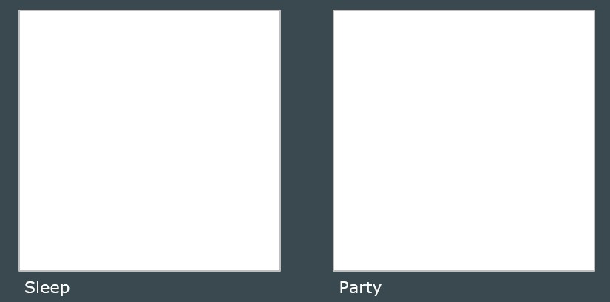

### EXPLAIN



5 MIN

**Summary**

To do design means to precisely **pay attention to your sensations**, to think about existing representations, and to **open your mind**.